男子組個人賽 Men’s Division - Single
NO. | Country | Last name/ First | Photo
1 | Brunei | Mohammad Azim | 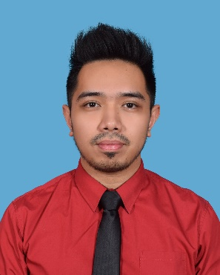
2 | China Hong Kong | Kong, Bu Hong, Andrew | 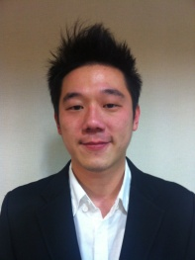
3 | Japan | Lo Li Wen | 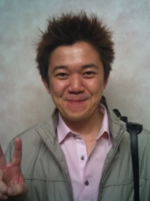
4 |  | OI Naoyuki | 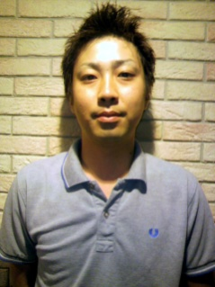
5 |  | Hijikata Hayato | 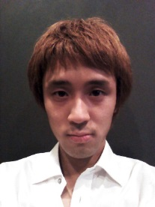
6 |  | Takenaka Hiroshi | 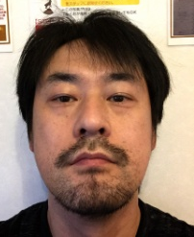
NO. | Country | Last name/ First | Photo
7 | Japan | Kuribayashi Toru | 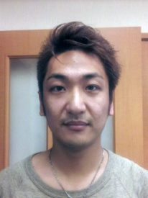
8 | Korea | Jeone Young Hwa | 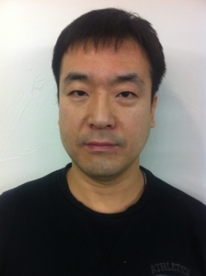
9 |  | Lee Wan Su | 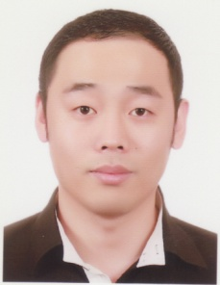
10 |  | Ryo Seung Woo | 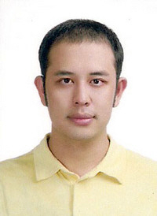
11 |  | Lee Jun Ho | 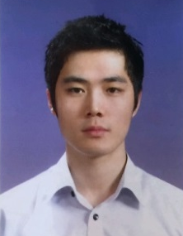
12 | Kingdom of Saudi Arabia | Alammar, Abdulrahman  Abdulaziz N | 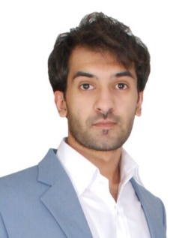

NO. | Country | Last name/ First | Photo
13 | Kingdom of Saudi Arabia | Alshammari, Abdullah Saeed O | 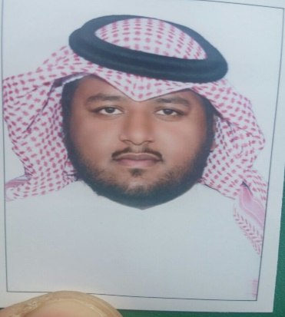
14 | Malaysia | Kok Jken Yung
15 |  | Casper Chin | 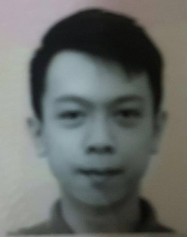
16 | Philippine | Efren Reyes
17 |  | Francisco Bustamante | 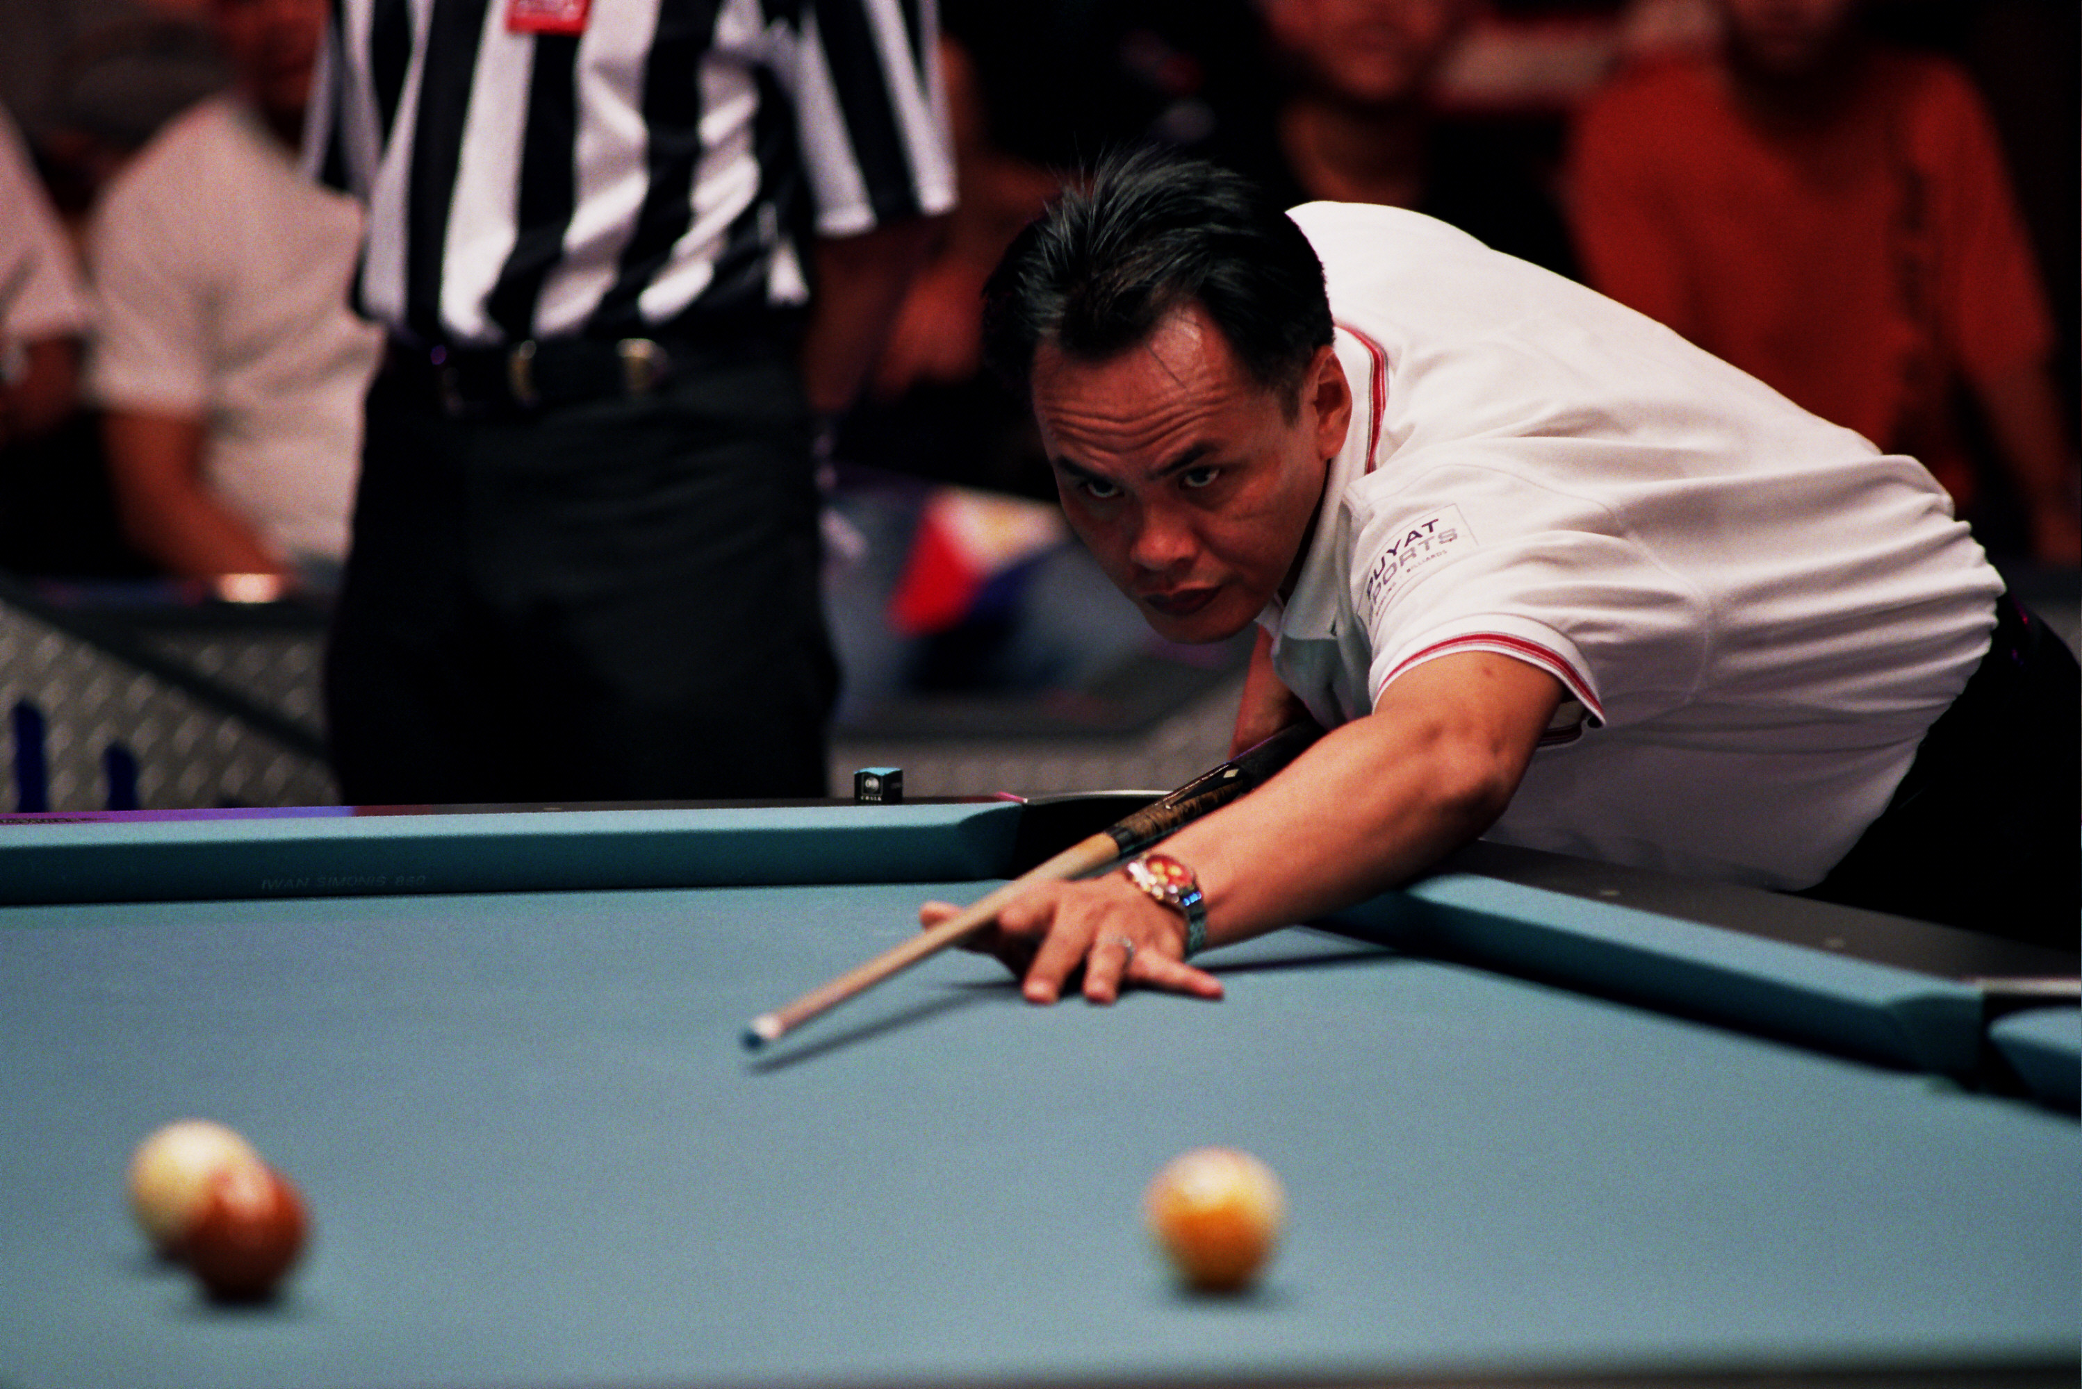
18 | Qatar | Bashar Hussain

NO. | Country | Last name/ First | Photo
19 | Qatar | Waled Majid | 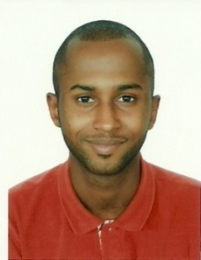
20 |  | Abdulatif Alfawal | 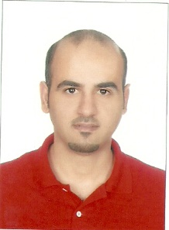
21 |  | Ali Abdulhadi Almarri | 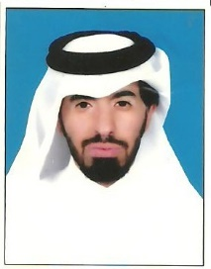
22 | Singapore | Aloysius Yapp | 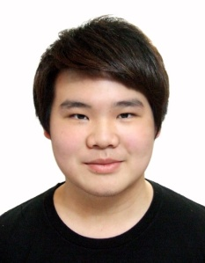
23 |  | Lim Zhu Kang | 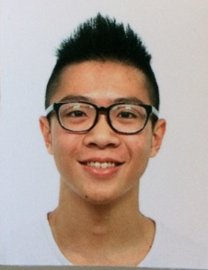
24 | Chinese Taipei | Ko, Pin-Yi 柯秉逸

NO. | Country | Last name/ First | Photo
25 | Chinese Taipei | Cheng, Yu-Hsuan鄭喻軒 | 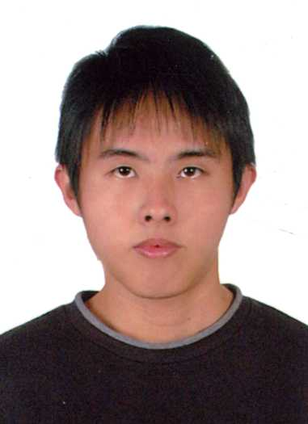
26 |  | Ko, Ping-Chung 柯秉中 | 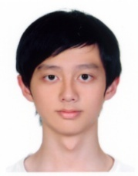
27 |  | Chu, Hung-Ming朱宏銘 | 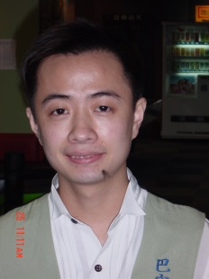
28 |  | Wu, Kun-Lin 吳坤霖 | 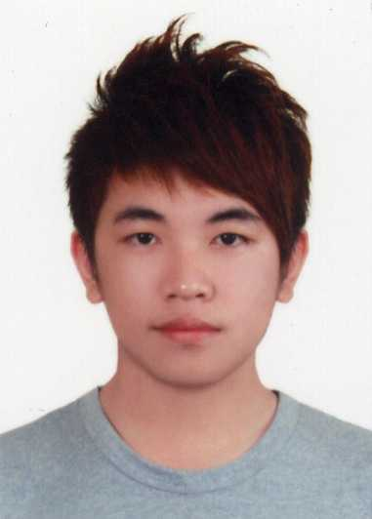
29 |  | Yeh, Chen-Lun葉鎮綸 | 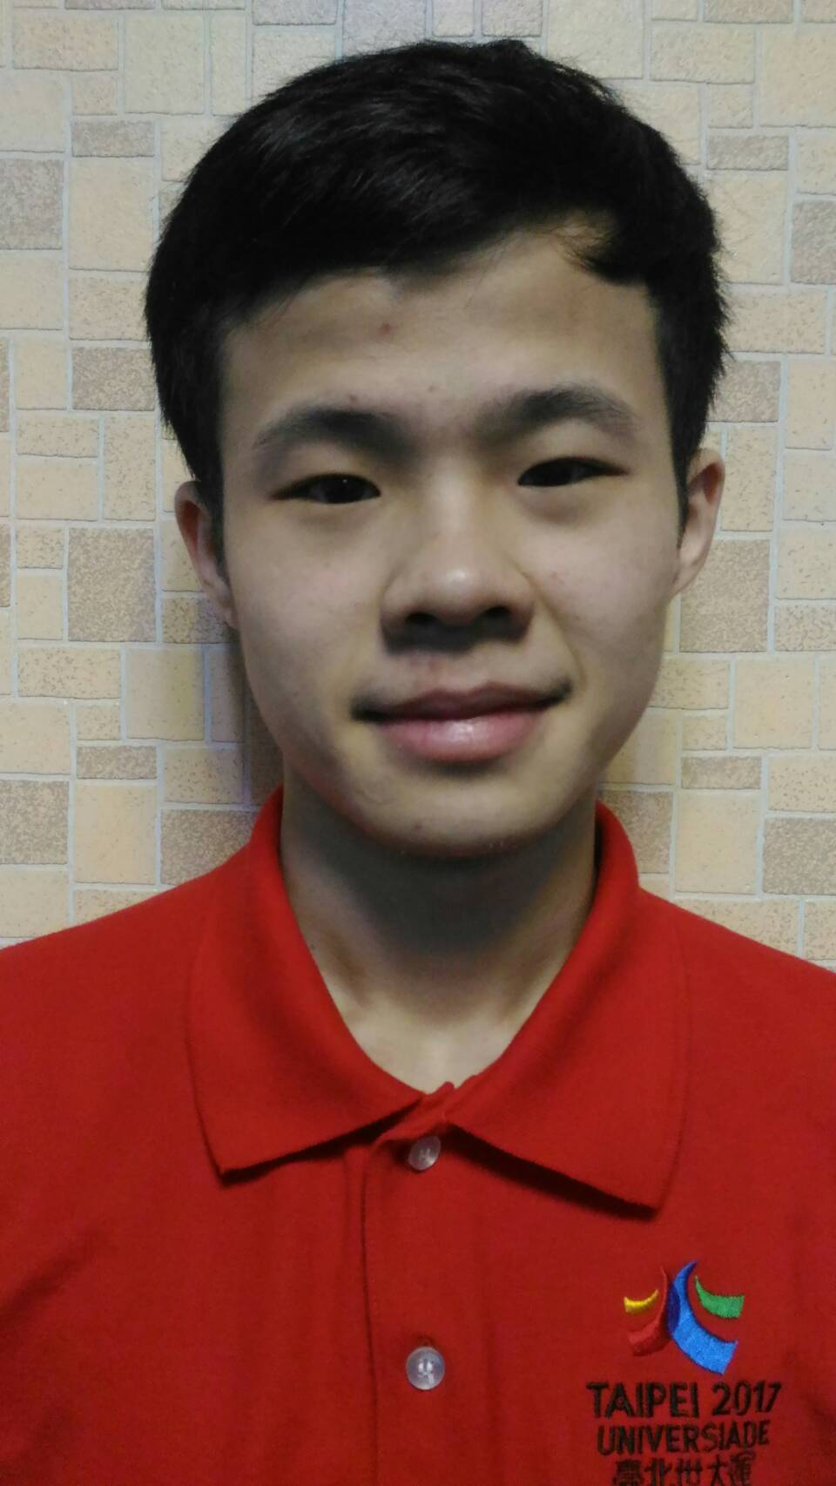

NO. | Country | Last name/ First | Photo
30 | Chinese Taipei | Fang, Wei-Chung方韋中 | 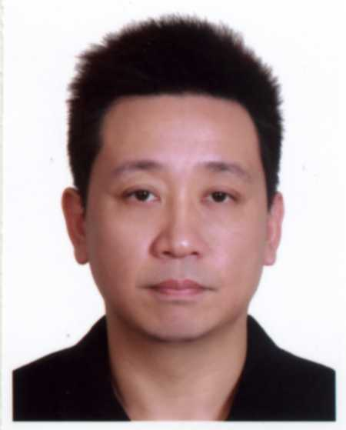
31 |  | Hsu, Jui-An許睿安 | 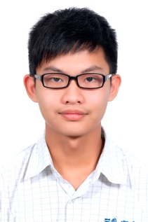
32 |  | Yang, Gong-Hao楊恭豪 | 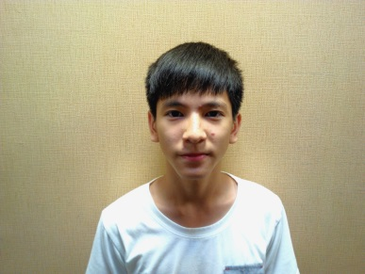

青少男組個人賽
Junior Division - Boy’s Single
NO. | Country | Last name/ First | Photo
1 | Brunei | HjHasnanHjMuhdKhairuddin
2 |  | QarinMuhammad Haikal | 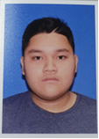
3 | China Hong Kong | Lo Ho Sum盧浩琛 | 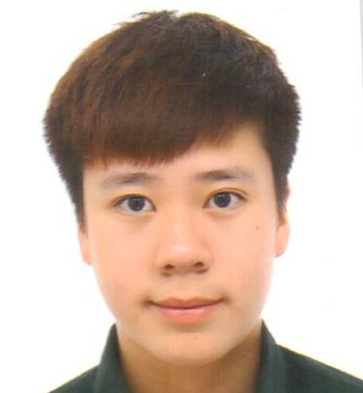
4 |  | Robbie James Joaquin CAPITO | 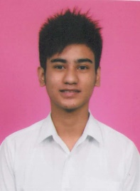
5 |  | Wong Yan 黃 仁 | 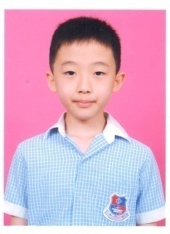
6 |  | Yip Kin Ling Leo葉建寧 | 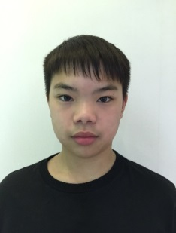

NO. | Country | Last name/ First | Photo
7 | Japan | TanakaTaiki | 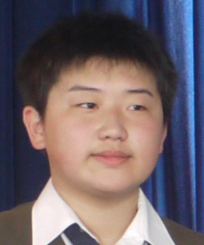
8 |  | NishiokaMisaki
9 | Korea | KyoungKyu Min | 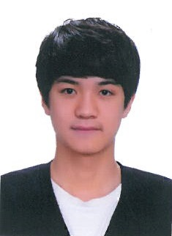
10 |  | NAInHak | 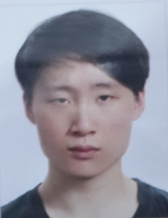
11 |  | Park Jung Min | 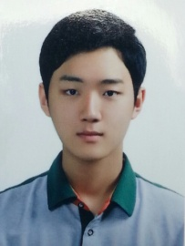
12 |  | SeoYoung Won | 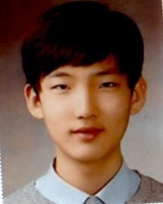
13 | Malaysia | Darryl Chia Soo Yew | 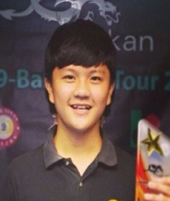

NO. | Country | Last name/ First | Photo
14 | Malaysia | Muhammad Almie B Muhamad Yakup | 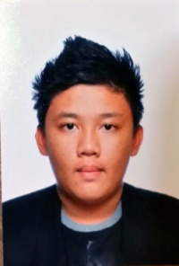
15 | Philippine | Jefrey Roda | 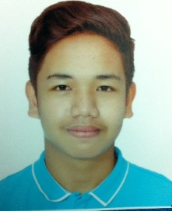
16 | Chinese Taipei | Tang, Jing-Ting唐境霆 | 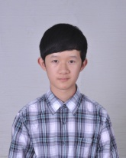
17 |  | Wang, Xing-Han王星翰 | 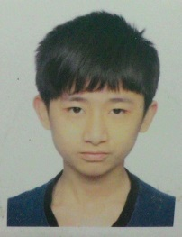
18 |  | Huang, Peng-Ren黃鵬仁 | 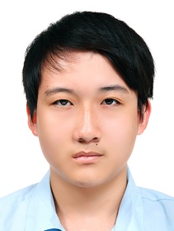
19 |  | Wu, Shih-Hao吳式濠 | 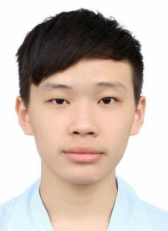
20 |  | Ko, Ping-Han柯秉漢 | 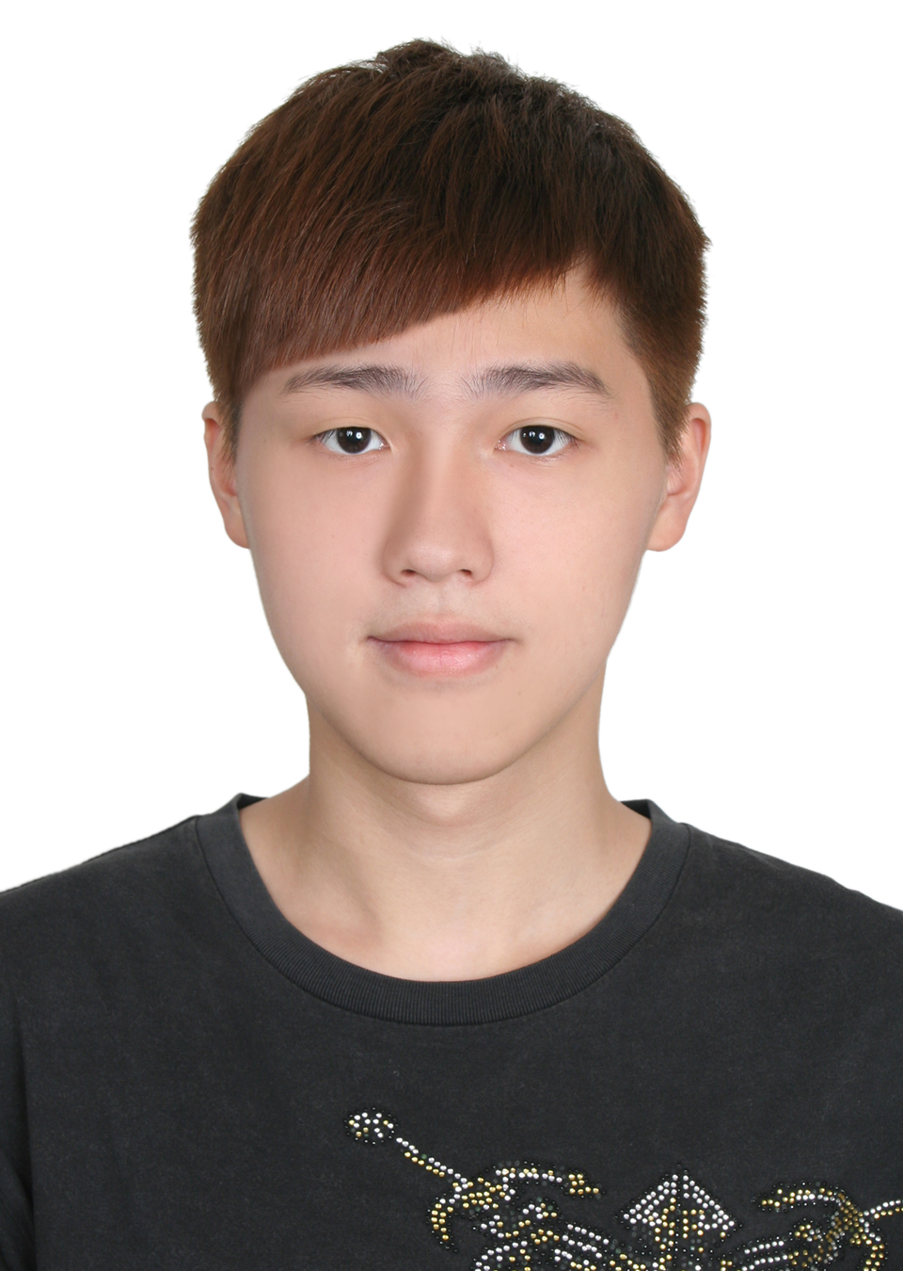

青少女組個人賽
Junior Division - Girl’s Single
NO. | Country | Last name/ First | Photo
1 | Japan | Okuda Tamami | 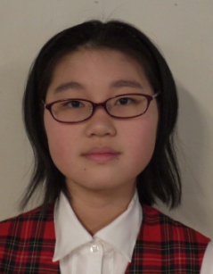
2 |  | Muramatsu Sakura
3 | KOREA | Kim Bo Geon | 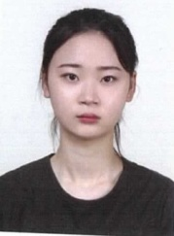
4 |  | Lee Woo Jin | 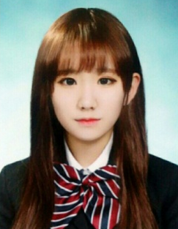
5 |  | Seo Seoa | 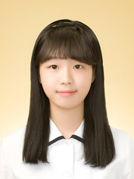
6 |  | Yeom Hee Ju

NO. | Country | Last name/ First | Photo
7 | Philippine | Chezka Centeno | 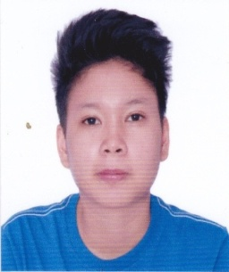
8 | Chinese Taipei | Chen, Jia-Hua陳佳樺 | 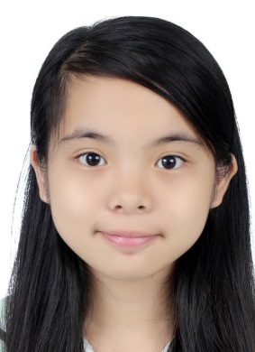
9 |  | Fan, Yu-Xuan范育瑄 | 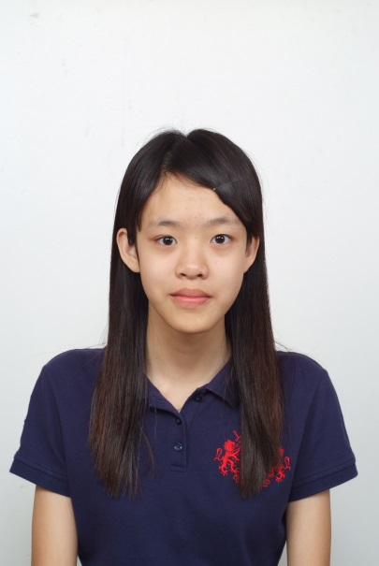
10 |  | Li, Xin-Yu李心語 | 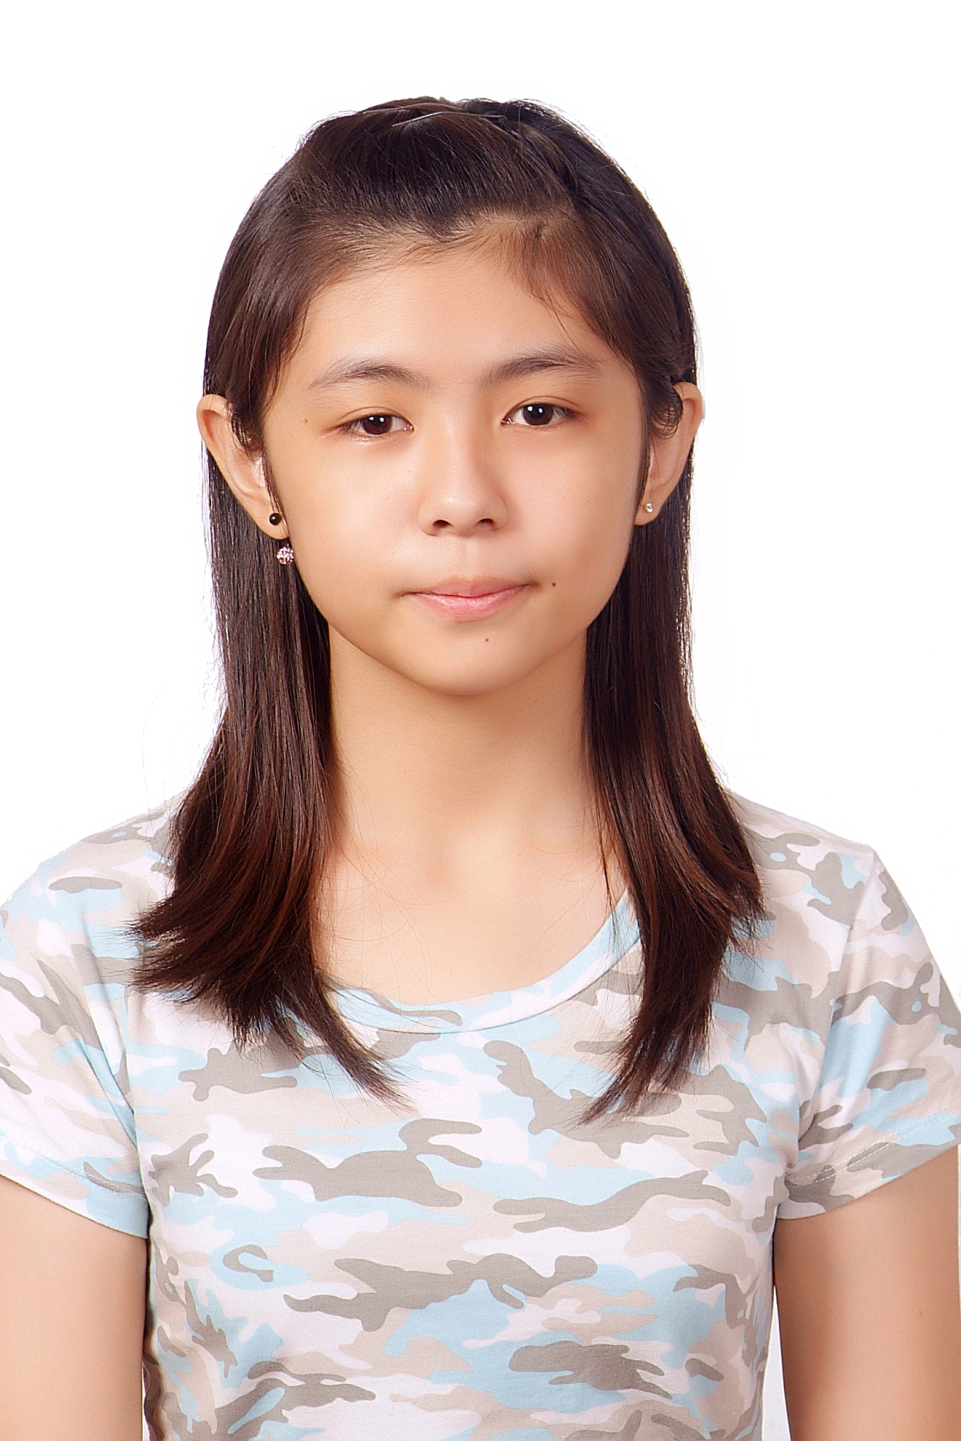
11 |  | Tsai, Pei-Chun蔡佩君 | 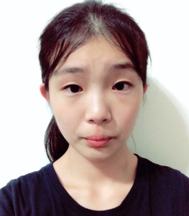
12 |  | Lin, Yi-Xuan林怡瑄 | 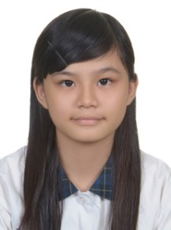

青少男組雙打賽
Junior Division - Boy’sDouble
NO. | Country | Last name/ First | Photo
1 | Brunei | HjHasnanHjMuhdKhairuddin
 |  | Qarin Muhammad Haikal
2 | China Hong Kong A | Lo Ho Sum
 |  | Robbie James Captio
3 | China Hong Kong B | Wong Yan
 |  | Yip Kin Ling Leo

NO. | Country | Last name/ First | Photo
4 | Japan | Tanaka Taiki
 |  | NISHIOKA Misaki
5 | Korea A | KyoungKyu Min
 |  | NAInhak
6 | Korea B | Park Jung Min
 |  | SEOYoung Won

NO. | Country | Last name/ First | Photo
7 | Malaysia | Darryl Chia Soo Yew
 |  | Muhammad Almie B Muhamad Yakup
8 | Chinese Taipei A | Tang, Jing-Ting唐境霆
 |  | Ko, Ping-Han柯秉漢 | 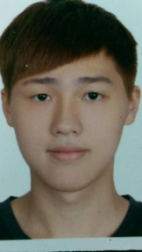
9 | Chinese Taipei B | Wang, Xing-Han王星翰
 |  | Zhuang, Nian-Xiang庄念享 | 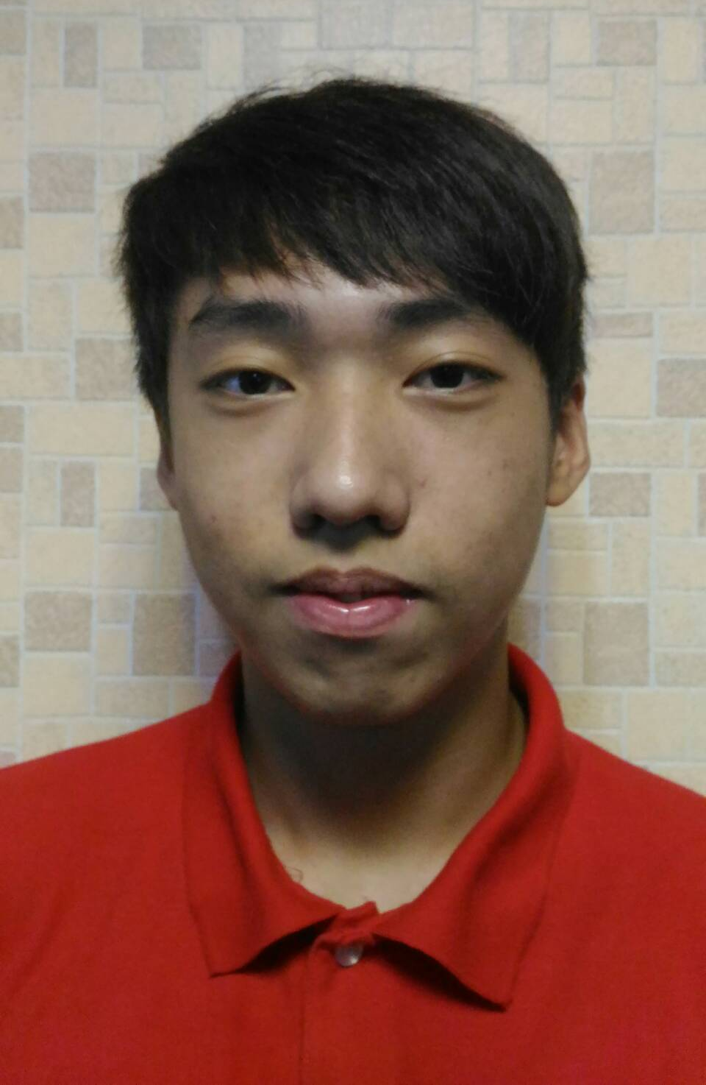

NO. | Country | Last name/ First | Photo
10 | Chinese Taipei  C | Huang, Peng-Ren黃鵬仁
 |  | Yeh, Li-Wen葉力文 | 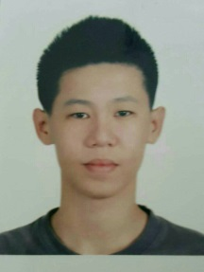

青少女組雙打賽
Junior Division - Girl’s Double
NO. | Country | Last name/ First | Photo
1 | Japan | Okuda Tamami
 |  | Muramatsu Sakura
2 | Korea A | Kim Bo Geon
 |  | LEE WOO JIN
3 | Korea B | SEO SEOA
 |  | Yeom Hee Ju

NO. | Country | Last name/ First | Photo
4 | Chinese Taipei A | Chen, Jia-Hua陳佳樺
 |  | Fan, Yu-Xuan范育瑄
5 | Chinese Taipei B | Li, Xin-Yu李心語
 |  | Tsai, Pei-Chun蔡佩君
6 | Chinese Taipei C | Wang, Ya-Yan王亞宴
 |  | Lai, Xin-Ya賴薪雅 | 