PRESS RELEASE JAKARTA 22 APRIL 2010

GUINNESS RISE TO THE CHALLENGE MAKES ITS FIRST BREAK
GUINNESS AS THE NO.1 STOUT IN THE WORLD IS CONTINUING ITS INNOVATION IN CREATING EXCITEMENTS THROUGH GUINNESS WORLD SERIES OF POOL 2010 – 10 BALL CHALLENGE BY MAKING ITS FIRST BREAK IN 13 CITIES THROUGHOUT INDONESIA TO FIND INDONESIA WORLD POOL MASTERS, BROADCASTED BY ESPN STAR SPORT, ACKNOWLEDGED BY POBSI INDONESIA

Jakarta, 22 April 2010, GUINNESS® as the No.1 Stout in the world, has been a great support in sports around the world from Rugby in England, Hurling in Ireland , now Guinness Indonesia presents the Guinness World Series of Pool 2010 – 10 Ball Challenge in Indonesia. This pool competition innovatively excites Indonesian to “Rise together and Rise to the Challenge”. The Guinness World Series Pool 2010 – 10 Ball Challenge season will start from April and ends on August 2010 as the grand final at Mall Taman Anggrek, Jakarta. This Year the competition will be covering 13 cities around Indonesia, starting from Medan to Ambon.

Guinness conducts World Series of Pool 2010 – 10 Ball Challenge in 13 cities in Indonesia such as Jakarta, Medan, Surabaya, Bandung, Yogyakarta, Palembang, Pekanbaru, Manado, Bali, Ambon, Palu, Pontianak and Makassar. along with international acknowledgment with 6 brand ambassadors, 32 international players and total of U$ 95,000 as the grand prize. Among the Guinness WSOP 6 brand ambassadors that came from representative countries such as Finland (Mika Immonen), USA (Johnny Archer and Shane Van Boening), Germany (Thorsten Hohmann) , Philipinne (Alex Pagulayan) and Indonesia is being reprensented by Riky Yang. This event is also organized by ESPN STAR Sports and sanctioned by Asian Pocket Billiard Union (APBU) and (POBSI) Indonesian Billiards Association for 10 Ball.

John Galvin – representative of Guinnes opens, ” Guinness World Series of Pool 2010 – 10 Ball Challenge demonstrates Guinness commitment as the No.1 Stout in the world in seek of No.1 Indonesian Pool Master. Hence, it is a proud moments for us by holding Guinness Series of Pool – 10 Ball Challenge in Indonesia every year for the past three years”. “ We are giving the opportunities for everybody to be the first, not only to Guinness loyal consumers but also to amateur players are able to participate in this event.”

Guinness World Series of Pool 2010 – 10 Ball Challenge proves Guinness commitment to sports globally by holding Guinness Pool Series in Indonesia every year for the past three years. In the year of 2007 & 2008, Guinness 9 Ball Tour has gathered 12 participants countries around Asia/ APBU (Asian Pocket Billiard Union). Countries such as China, Hongkong, India, Indonesia, Japan, Korea, Malaysia, Philipinne, Singapore, Taiwan, Thailand, Vietnam have all joined in this competition. As for Indonesia, Guinness 9 Ball Tour in 2008 has received MURI record.

“ We are happy to be a part of Guinness World Series of Pool in Indonesia,” adds Victor Cui/ Harvey Davies - Representative of ESPN. “Not only are we able to collaborate with Asian Pocket Billiard Union (APBU) and (POBSI) Indonesian Billiards Association, but also we are able to participate in covering this event with international acknowledgment carries out by Guinness is a World Series of Pool competition that will be hold in 13 cities in Indonesia”.

In addition to the remarks above, Riky Yang also added, “ It’s an honor to represent Indonesia among these 6 brand ambassadors from around the world. Especially, to be a part of such an international event of Guinness World Series of Pool”. “C’mon Indonesia, show your spirit in the game and play to the max!”.

Guinness World Series of Pool would play 10 Balls with entry fee of Rp. 50.000 to enter the tournament qualifiers. Preliminary round covers 64 qualifying players that will play based on elimination system and they will able to advance to the Professional round. Professional round covers 64 players (32 from preliminary and 32 invited/seeded professional players) will play based on elimination system.

Guinness conducts World Series of Pool in 13 cities in Indonesia starts from Makassar (17 April 2010), Surabaya(25 April 2010), Medan (1 Mei 2010), Bali (1 Mei 2010), Palembang (5 Mei 2010), Pekanbaru (8 Mei 2010), Palu (8 Mei 2010), Jakarta (15 Mei 2010), Bandung (15 Mei 2010), Manado (15 Mei 2010), Ambon (15 Mei 2010), and Pontianak (22 Mei 2010).

Guinness World Series of Pool will announce elements of pool activities while enjoying Guinness trough out the season starting from pool coaching clinic, augmented reality pool game, digital pool competition, guess trick pocket, surprised 10 ball activities and mobile pool table. Within this event also includes media writing competition, media photo competition as well as 1000 photo Guinness World Series of Pool. So be ready because one of you is able to be the winner and have the chance to challenge the professional players in this international event and bring home the grand price.

-Ends-
About Guinness Indonesia
While unofficial evidence shows that Guinness was available in Indonesia since 1930, formally the Guinness history in Indonesia started in July 1973, when GUINNESS OVERSEAS LTD. (London) established PT. Guinness Indonesia under the leadership of Patrick Lawlor. In 1974, Guinness started local production with PT. Multi Bintang Indonesia. The product variant that is produced up to today was Guinness Foreign Extra Stout, which is sold widely in Asia, the Caribbean and Africa.
In 1981, the company name was changed to PT. Gitaswara Indonesia and the business continued rapid growth. Today Indonesia is the sixth largest Guinness market in the world and continues to grow.

For press enquiries please contact:
Hafni S Damayanti
Senior Account Manager
Pulse Communications
Tel. 021 7232383 ext 272
Fax. 021 7232409
Email: hafni.damayanti@pulse-indo.com

PRESS RELEASE JAKARTA 22 APRIL 2010

GUINNESS WORLD SERIES OF POOL MEMBUAT GEBRAKAN PERTAMANYA

Guinness membawa Indonesia kepada kompetisi yang luar biasa. Sebagai bagian dari kampanye global ‘Guinness Rise Together’, Guinness mengadakan acara untuk pertama kali, turnamen internasional – Guinness World Series of Pool – 10 Ball Challenge yang menampilkan talenta-talenta biliar lokal dengan Master Dunia di 13 kota di Indonesia.

Jakarta, 22 April 2010 - Guinness telah mendukung dan mengembangkan olahraga di seluruh dunia dimulai dari Rugby di Inggris, Hurling di Irlandia dan Biliar di Indonesia dengan meluncurkan Guinness World Series of Pool 2010 – 10 Ball Challenge di Indonesia. Kompetisi billiar ini secara inovatif bertujuan untuk memeriahkan masyarakat Indonesia melalui kampanye “Rise together and Rise to the Challenge”. Guinness World Series Pool 2010 –10 Ball Challenge akan dimulai dari bulan April hingga bulan Agustus 2010 dan grand final akan bertempat di Mall Taman anggrek, Jakarta. Kompetisi tahun ini akan meliputi 13 kota diseluruh Indonesia, dimulai dari Medan hingga Ambon.

Guinness menyelenggarakan World Series of Pool 2010 –10 Ball Challenge di 13 kota di Indonesia yang akan dimulai dari Makassar, Surabaya, Yogyakarta, Palembang, Pekanbaru, Manado, Bali, Ambon, Palu, Pontianak dan berakhir di Jakarta untuk Grand Final. Guinness World Series of Pool merupakan sebuah acara yang pertama kali diadakan, yaitu turnamen Internasional di Indonesia yang diikuti oleh 32 pemain internasional menampilkan pemain terbaik Indonesia melawan pemain terbaik dunia dengan total hadiah senilai 95.000 USD. Untuk turnamen ini, Guinness membawa 32 pemain internasional dan 6 brand ambassador yang hadir mewakili negara-negara seperti Finland (Mika Immonen), USA (Johnny Archer dan Shane Van Boening), Germany (Thorsten Hohmann) , Philipinne (Alex Pagulayan) dan Indonesia diwakilkan oleh Riky Yang. Acara ini juga diselenggarakan oleh ESPN STAR Sports dan dinilai oleh Asian Pocket Billiard Union (APBU) dan (POBSI) Indonesian Billiards Association untuk 10 Ball.

John Galvin – perwakilan dari Guinness membuka, “Guinness World Series of Pool 2010 – 10 Ball Challenge mewujudkan komitmen Guinness dalam mempertajam talenta lokal dan menampilkannya melawan Master Dunia. Ini merupakan momen yang membanggakan bagi kami dalam menyelenggarakan acara ini di Indonesia selama 3 tahun terakhir.” Kami memberikan kesempatan kepada semua orang untuk menjadi yang pertama, bukan hanya bagi konsumen Guinness, tapi pemain amatir juga bisa berpartisipasi di event ini.

“Kami sangat bahagia dapat bekerjasama dengan Guinness terutama dalam acara yang penuh dengan momen berharga ini – Guinness World Series of Pool di Indonesia,” tambah Harvey Davies – perwakilan dari ESPN. “Tidak hanya dapat bekerjasama dengan Asian Pocket Billiard Union (APBU) dan (POBSI) Persatuan Olahraga Biliar Seluruh Indonesia, tetapi juga dapat ikut serta dalam meliput acara ini dengan pengakuan internasional yang diselenggarakan oleh Guinness yaitu kompetisi World Series of Pool yang akan diselenggarakan di 13 kota di Indonesia”.

Guinness World Series of Pool merupakan sebuah kesempatan yang menarik untuk melanjutkan dukungan Guinness di industri olahraga biliar. Acara ini akan memberikan Guinness kesempatan dalam berinteraksi dengan konsumen dan menyediakan mereka beragam kesempatan dalam berkompetisi melawan pemain terbaik dunia melalui proses yang mempertajam talenta mereka sehingga dapat menjadi seperti Ricky Yang, salah satu Cuemaster terbaik di dunia yang berasal dari Indonesia.

Sebagai tambahan pernyataan diatas, Ricky Yang juga menambahkan, “Suatu kebanggaan dapat mewakili Indonesia dan menjadi salah satu dari 6 brand ambassador dari seluruh dunia. Terutama saya sangat bangga dapat mengikuti acara bertaraf internasional dan bergengsi seperti Guinness World Series of Pool ini”. “Ayo Indonesia, tunjukkan semangat mu dalam kompetisi ini dan bermainlah sampai akhir!”.

Guinness menyelenggarakan World Series of Pool – 10 Ball Challenge sesi kualifikasi di 13 kota di Indonesia dimulai dari Makassar 17 April 2010), Surabaya(25 April 2010), Medan (1 Mei 2010), Bali (1 Mei 2010), Palembang (5 Mei 2010), Pekanbaru (8 Mei 2010), Palu (8 Mei 2010), Jakarta (15 Mei 2010), Bandung (15 Mei 2010), Manado (15 Mei 2010), Ambon (15 Mei 2010), dan Pontianak (22 Mei 2010).

Guinness World Series of Pool telah di disain khusus baik bagi penggemar biliar dan non-biliar dengan ragam akifitas yang menyenangkan dan luas terdiri dari klinik pelatihan biliar dan Augmented Reality Pool Game. Satu kompetisi penulisan media, kompetisi foto media serta 1000 foto Guinness World Series of Pool yang termasuk di dalam acara ini. Maka bersiaplah untuk ‘Rise to The Challenge’ dan dapatkan tantangan dari pemain-pemain internasional di acara bertaraf internasional ini dan bawalah pulang hadiah utama.
-Ends-
Mengenai Guinness Indonesia
Walau beberapa sumber yang tidak resmi menunjukkan bahwa Guinness telah ada di Indonesia sejak tahun 1930, namun sejarah resmi Guinness di Indonesia dimulai pada bulan Juli 1973, saat GUINNESS OVERSEAS LTD. (London) mendirikan PT. Guinness Indonesia dibawah pimpinan Patrick Lawlor.

Di tahun 1974, Guinness memulai produksi lokal dengan PT Multi Bintang Indonesia. Varian produk yang diproduksi sampai dengan saat ini adalah Guinness Foreign Extra Stout yang dijual secara luas di Asia, kepulauan Karibia dan Afrika. Pada tahun 1981, nama perusahaan diubah menjadi PT. Gitaswara Indonesia dan bisnis terus berkembang. Saat ini Indonesia telah menjadi market terbesar nomor 6 Guinness di dunia dan terus bekembang.
Kata Guinness dan logo terkait merupakan hak cipta. ©Guinness & Co. 2008

For press enquiries please contact:
Veronica M. Utami
Account Executive
Pulse Communications
Tel. 021 7232383 ext 169
Fax. 021 7232409
Email: veronica.utami@pulse-indo.com
FACT SHEET
GUINNESS WORLD SERIES OF POOL GAME COMPETITION

- HAPPENING ACTIVITY ( April - first May)
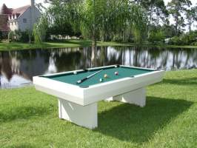
- It is the basic activity flow of the happening:
- Two People bring a mobile pool table, and set it up in unexpected places
- After they prepare the table, later followed by preparation of the ten ball formation
- Two ‘actor’ players + 1 Black Angel show up and play the 10 balls in the middle of the public places to gain mass attention for 15-30 minutes
- They will invite people around there to
- Play against one of them (sometimes the invitation is only a teasing process)
- Some recommended points:
- Intersections
- Bus Shelter
- Entrance Area of a Building complex
- Building Lobby Area (Office, Mall, etc)
- On a side of main road
- There are 4 – 8 points* to visit per day per team, conducted in MAX 2 days per city

- AUGMENTED REALITY POOL GAME ( April onwards)
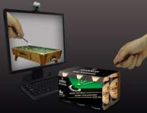
- Guinness will introduce a new way of playing 10 balls anywhere, everywhere, without having to bring a pool table:
- Buy 3 or 6 packs can
- Embed product package with AR code
- on the ground: outlet provide webcam for costumers to use
- online: download program and play online at home is unpredictable.

- ONLINE POOL COMPETITION (Mei-July 2010)
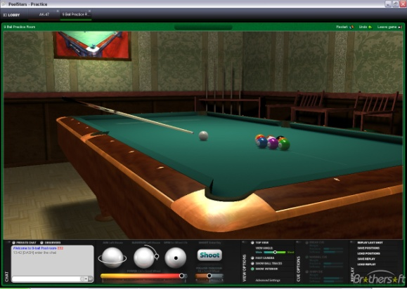
- Players will play through website www.guinnessworldpool.com . The best 8 will be playing in Jakarta to get the best scorer.
- Players will be given an online tool / guidelines to design a pool table (and/or cue stick and balls).
- Winners will be given a grand prize of pool table in miniatur size.
- Player’s design will be realization at Grand Final Guinness World Series of Pool 2010 event

- TWITTER – daily Trivia (June-July 2010)

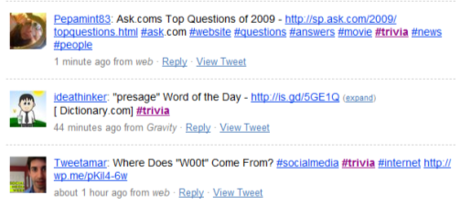

- Twitter skin is customize with 10Balls theme
- Create trivia quiz every day
- Topic is always about pool, world pool, etc
- Follower’s answer with certain #hashtag
- Point system
Follower who answers the question quickly and correctly will have 1 point
In the end of the week, follower who has the biggest point will win

- FACEBOOK – QUIZ (June-July 2010)

- Facebook Quiz to choose a winner who will get a wildcard to play on Grand Final / play with national player
- Quiz will consists of several phases to decide one winner

FACT SHEET

GUINNESS WORLD SERIES OF POOL ‘THE COMPETITION’

- MEDIA WRITTING COMPETITION
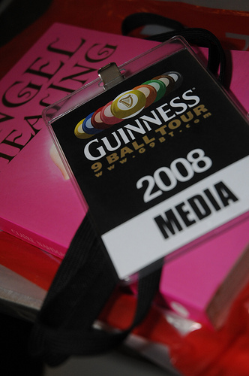
Guinness invites the media to join Guinness Writing Competition. The coverage should tell about Guinness World Series of Pool event from qualification to Grand Final.
The winner will be announced after the Grand finale of World
Series of Pool

- MEDIA PHOTO COMPETITION
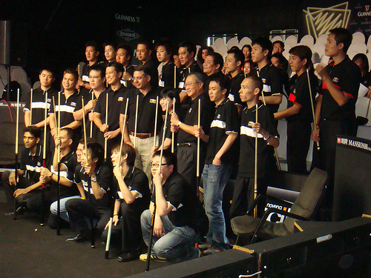
Guinness invites everyone to join Photo competition focusing on WSOP ambiance with Guinness World Series of Pool tour memorabilia. The winner will be announced at the Grand final and will get Guinness special prize.

- ONE THOUSAND PHOTO OF GUINNESS WORLD SERIES OF POOL 2010
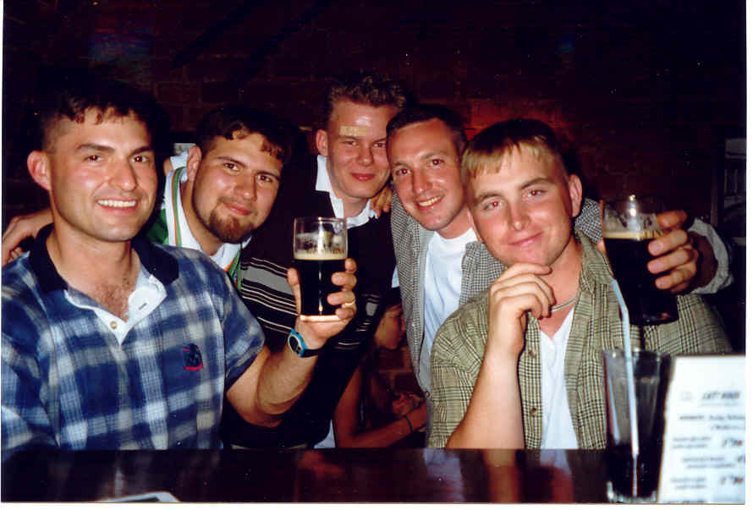
A campaign that invites audiences & attendees to be part of “one thousands photos of GWSOP” ~ break record of most people taking photo with Guinness Merch within 3 days.
Gimmicks for people with the best photo & submit the best quality photo
Upload on: Flickr, Facebook, Blog, Tweetphoto, etc. Using #hashtag or link back.
*Pull all those onto one website
- scheme table of qualification game
- Guinness Mobile Pool
- Labyrint
FACT SHEET
Rules of Play For 10 ball

Ten Ball (effective from 1 Jan 2009)
Ten ball is a call shot game played with ten object balls numbered one through ten and the cue ball. The balls are played in ascending numerical order and the lowest numbered ball must be contacted by the cue ball in order to establish a legal hit. If the ten ball is pocketed on a legal break shot, it will be spotted and the player continues with his inning. Only one ball may be called on each shot, except on the break shot where no ball may be called. (See 5 Call Shots & Pocketing Balls).
1. Determining the Break
The player who wins the lag chooses who will break the first rack. The standard format is to alternate the break, but see Regulation 15, Subsequent Break Shots.
2. Ten Ball Rack
The object balls are racked as tightly as possible in a triangular shape, with the one ball at the apex of the triangle and on the foot spot and the ten ball in the middle of the triangle. The other balls will be placed in the triangle without purposeful or intentional pattern.
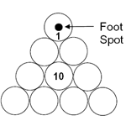
Ten Ball Rack
3. Legal Break Shot
The following rules apply to the break shot:
(a) the cue ball begins in hand behind the head string; and
(b) if no ball is pocketed, at least four object balls must be driven to one or more rails, or the shot is a foul.
4. Second Shot of the Rack ?Push Out
If no foul is committed on the break shot, the shooter may choose to play a ush out?as his shot. He must make his intention known to the referee, and then rules 6.2 Wrong Ball First and 6.3 No Rail after Contact are suspended for the shot. If no foul is committed on a push out, the other player chooses who will shoot next. The ten ball pocketed during a Push Out is spotted, without penalty.
5. Call Shots & Pocketing Balls
Whenever the shooter is attempting to pocket a ball (except the break) he is required to call shots, the intended ball and pocket must be indicated for each shot if they are not obvious. Details of the shot, such as cushions struck or other balls contacted or pocketed are irrelevant.
For a called shot to count, the referee must be satisfied that the intended shot was made, so if there is any chance of confusion, e.g. with bank, combination and similar shots, the shooter should indicate the ball and pocket. If the referee or opponent is unsure of the shot to be played, he may ask for a call.
6. Safety
The shooter, after the break at anytime may call safety? which permits him to make contact with the legal object ball without pocketing a ball and end his inning. However, if the shooter pockets the legal object ball the incoming player has the option to play the shot as left, or hand it back to his opponent.
7. Wrongfully Pocketed Balls
If a player misses his intended ball and pocket, and either makes the nominated ball in the wrong pocket or pockets another ball, his inning has finished and the incoming player has the option to take the shot as is, or hand it back to his opponent.
8. Continuing Play
If the shooter legally pockets a called/nominated ball on a shot (except a push out, see 4. Second Shot of the Rack ? Push Out), any additional balls pocketed remain pocketed (except the ten ball; see 9. Spotting Balls), and he continues at the table for the next shot. If he legally pockets the called ten ball on any shot (except a push out), he wins the rack. If the shooter fails to pocket the called ball or fouls, play passes to the other player, and if no foul was committed, the incoming player must play the
cue ball from the position left by the other player.
9. Spotting Balls
If the ten ball is pocketed on a foul a push out or during the break shot, or without calling it, or accidentally in the wrong pocket, or driven off the table, it is spotted. No other object ball is ever spotted.
10 Standard Fouls
If the shooter commits a standard foul, play passes to his opponent. The cue ball is in hand, and the incoming player may place it anywhere on the playing surface. The following are standard fouls at ten ball:
1. Cue Ball Scratch or off the Table
2. Wrong Ball First The first object ball contacted by the cue ball on each shot must be the lowest-numbered ball remaining on the table.
3. No Rail after Contact
4. No Foot on Floor
5. Ball Driven off the Table The only jumped object ball that is spotted is the ten.
6. Touched Ball
7. Double Hit / Frozen Balls
8. Push Shot
9 .Balls Still Moving
10. Bad Cue Ball Placement
12. Cue Stick on the Table
13. Playing out of Turn
14. Slow Play top
11 Serious Fouls
For Three Consecutive Fouls, the penalty is loss of the current rack. For Unsportsmanlike Conduct, the referee will choose a penalty appropriate given the nature of the offense.
12 Stalemate
If a stalemate occurs the original breaker of the rack will break again.

FACT SHEET
GUINNESS WORLD SERIES OF POOL

Event : Guinness World Series of Pool 2010

Date : July 28 – Aug 1, 2010 (TBC)

Venue : Jakarta

Organized : ESPN STAR Sports

Sanctioned By : Asian Pocket Billiard Union (APBU)
(POBSI) All Indonesian Billiards Association

Title Sponsor : Guinness

Official Broadcaster : STAR Sports

Total number of players : 64 players

TV Coverage :15 hours (Saturday & Sunday)
45 hours repeats (3 repeats of the programme)

EVENT SUMMARY

10ball competition
Five (5) day event Competition Day 1 Preliminary Rounds - Double Elimination
Competition Day 2 Preliminary Rounds - Double Elimination
Competition Day 3 Professional Rounds - 64 Bracket Rounds
Competition Day 4 Professional Rounds - 64 Bracket Rounds
Competition Day 5 Final Rounds - Quarterfinals, Semi finals & Final

Preliminary rounds
- 64 qualifying players is comprised of 40 winners from the 5 cities qualifiers and 24 players from open qualifying

Professional rounds
- Total 64 players (32 from preliminary rounds and 32 invited/seeded professional players.)
- All invited 32 professionals are seeded and move directly to the Final Rounds. These 32 professionals are comprised of below (TBC):
6 invited by organizer
6 from host country
6 from APBU (according to ranking – TBC)
6 from America (according to ranking – TBC)
6 from Europe (according to ranking – TBC)
2 from other continents or APBU – TBC
Entry Fees: Entry fee will be charged for only Rp. 50.000 to enter the tournament qualifiers.

World Series Prize Purse : US$95,000
(Subject to sanction fee and local government tax)

Breakdown: World Series Prize Purse USD95,000
Champion US$40,000
Runner-up US$10,000
3rd US$6,000
4th US$5,000
5th US$4,000
6th US$3,000
7th US$2,000
8th US$1,000
9th – 15th US$ 800
16th – 31st US$ 500
32nd – 64th US$ 300

Five (5) City Qualifier Events: Qualifier events in five Indonesian cities
They are: (1) Surabaya, (2) Makassar, (3) Pekanbaru or Palembang(TBC), (4) Medan, (5) Jakarta and grand finals in Jakarta

City Qualifying #1 Apr 29 – May 9
City Qualifying #2 May 6 – May 16
City Qualifying #3 May 13 – May 23
City Qualifying #4 June 2 – June 10
City Qualifying #5 July 20 – July 27 (TBC)

Top 8 (TBC) from each city to earn a free entry into the World Series
GUINNESS will be taking charge of these events together with POBSI officials.

FORMAT FOR CITY QUALIFYING

1. Each city is 8 days qualifying + 3 days final.

2. City Daily Qualifying - each day open entries upto 32.

3. Multiple re-entries allowed if draw is not fully filled up during city qualifying.

- City Final - 32 players to plan on double elimination.

- Total 64 draw - comprise of top 32 from preliminary rounds + 32 professional players


The Man: ARTHUR Guinness
Innovator, campaigner and philanthropist

In 2009 we celebrate the life of a remarkable man, Arthur Guinness, founder of the GUINNESS brewery, entrepreneur, visionary and philanthropist.

Arthur Guinness left a remarkable legacy, but there is more to Arthur Guinness than the legendary beer he brought us. A renowned campaigner and social philanthropist, from the beginning he ensured his business continually gave something back to his employees, the local community, Dublin and the countries around the world in which GUINNESS does business. Arthur Guinness’ philanthropic legacy is something that defines the GUINNESSS brand to this day and will be further enhanced and celebrated in 2009.

Arthur had a lucky start – at the age of 27 (1752) his Godfather, the Rev Arthur Price, Archbishop of Cashel, bequeathed him £100 in his will. Arthur put the money to good use and four years later, at the age of 31, he was brewing under his own steam in Leixlip, just 17km from Dublin.

In 1759, Arthur Guinness took the momentous decision to head for the city and set up his own business, leaving his younger brother in charge of the Leixlip brewery. The rest is brewing history.

Despite 1759 not being the best time to become a Dublin brewer – taxes were stiff and local competition fierce, Arthur had belief and a shrewd eye for a deal. Acquiring a nine-thousand year lease to a run down, four-acre brewery at St. James’s Gate from Mark Rainsford for an annual rent of £45 – which crucially included water rights; Arthur was in business.

Arthur Guinness died in 1803, but brewing was already in the family. He left the St. James’s Gate brewery to his son Arthur (1768-1855). The beautiful dark beer that proudly bore Arthur Guinness’ name, and that of successive generations, was developed with a passion, evolving from prized assts...To cultural icon...to global brand: GUINNESS.

Notes to Editors:
Key milestones in Arthur Guinness’ life:

- Arthur Guinness is born in 1725 near Celbridge, County Kildare.
- 1752, Arthur Guinness is bequeathed £100 in Archbishop Price’s will. Quite a considerable amount of money at the time, Arthur put the money to good use and four years later, at the age of 31, he was an established brewer in Leixlip, just 17km from Dublin.
- In 1759, aged 34, confident young brewer Arthur took the momentous decision to head for the city and set up business on his own.
- On 1st December 1759 Arthur entered his signature into the Minute Book of the Dublin Corporation of Brewers, marking his achievement as an official new brewer.
- On 17th June 1761, two years after setting up business in Dublin the young entrepreneur pursued his impressive ascension by marrying 19 year old Olivia Whitmore.
- 1769, the first export shipment of six-and-a-half barrels of porter brewed at St. James’s Gate leaves Dublin on a sailing vessel bound for England.
- 1775: Water, water everywhere – Almost as soon as Arthur began brewing at St. James’s Gate, Arthur entered into dispute with the Dublin Corporation about water rights to the brewery, a dispute that went on many years.
- In 1786 Arthur founded the first Sunday school in Ireland.
- 1795 Now 70 years old, an aging Arthur still took an active role in the running of the brewery, visiting St. James’s Gate daily.
- Arthur Guinness died in 1803 at the age of 78 at his house in Gardiner Street in Dublin, but brewing was already in the family. He left the St. James’s Gate brewery to his son Arthur (1768-1855).

The GUINNESS word and associated logos are trade marks

The Expansion of Guinness

10 years after establishing his Brewery at St. James’s Gate, Arthur Guinness succeeded in his aim of taking his brew beyond Ireland’s shores. In a move typical of his innovative character, Arthur exported 6 and a half barrels of his beer on a ship to set sail for England in 1769. By 1817, exports had already reached the United States and continued to spread to Barbados, Trinidad and as far afield as Australia and New Zealand.

As the overseas popularity of GUINNESS grew, the company realized the importance of establishing a worldwide brand and in 1862 the famous GUINNESS trademark beer label was born. This became an international symbol of quality.

As well as expanding the distribution of GUINNESS throughout the world, 1929 heralded a new beginning for GUINNESS, with the first official national advertising campaign published in the British press. This was the start of the successful GUINNESS advertising that has spread over 80 years throughout the world, from the longest promotion, a bottle drop in 1959, to the first GUINNESS neon sign in 1931 to winning awards for the ‘Surfer’ commercial in 1999.

In 1936 the Guinness Company opened its first brewery overseas at Park Royal, London, and 1963 saw the establishment of the first brewery outside of the British Isles in Ikeja, Nigeria.
One of the biggest turning points in measuring the success of GUINNESS overseas was in 2000 when world sales finally exceeded home sales. From Togo to Russia to Guyana, consistently great GUINNESS is enjoyed today in as many as 150 countries around the world, whilst it is brewed in some 50 different nations.

Of course, the story of the black stuff’s expansion is a detailed and fascinating one. It is a tale intertwined with personality, science and modernization; a legend that spans multiple historical eras and includes barges, “World Travelers”, steam ships and, most importantly, the entrepreneurial flair which has come to be synonymous with the GUINNESS brand.

The GUINNESS word and associated logos are trademarks. (C) Guinness & Co. 2008

Tips Dealing with the Indonesian Media

General

Treat them as if they were your colleague or friend – they will be happy if treated as an equal, and not spoken “down to.”

Most media speak average English – but never attempt to conduct an interview in English without a competent person to translate and qualify the meaning.

The possibility of misquotation is very high – particularly if they are reporting in Bahasa Indonesia what you said in English.

The media are generally divided into categories of general and business, with limited specialization in certain fields.

They are not likely to be familiar with high-tech/jargon/foreign terms.

Speak slowly, simply and clearly – avoid “jargon words.” Help them to understand the terms.

When talking about your products/services, try to give the benefit or value of your products/services, rather than to promote them.

Journalists here are well known for asking about y our opinion about the government and political, economic, and social situation in Indonesia.

Do not be drawn into this line of questioning. Decline politely, explaining that it is not appropriate for you to comment on those topics.

When talking to a journalist, do not criticize any aspect of Indonesia – even about “the traffic.” It is seen as disrespectful or offensive for a foreigner to be critical.

Body Language / Voice - Speak calmly, not loudly; do not get angry; do not point your finger at the person; do not fold your arms in front of them nor put your hands on your hips; call them Pak (for men) or Ibu (for women).

Media Conference / Briefing / Gathering

Indonesia has legitimate journalists and fake journalists (who are after money). Real journalists are polite and are not keen on media allowance, although some still accept it. Fake journalists only want money. They are known for asking clients for some money.

When they ask for money, you should say, “It is not appropriate to deal with me on this, please speak to Pulse Communications as they are handling this matter.”

If the language barrier is a problem, the media will tend to be silent during the question and answer session.

Be friendly with them and throw in some humor, it will help to warm up the situation. Our MC will help to translate the questions and answers whenever necessary.

Answer only one question at a time, giving a very succinct, to-the-point answer, emphasizing the key messages.

Journalists tend to ask two or three questions in one go. Our MC will facilitate the Q&A and ask them to only ask one question at a time. However, if they ask more than one, only answer one question and allow the translator to translate before asking for the second question again.

After the media conference has been closed, the journalists will often crowd up to the panel members asking further questions, often persistently, and they may have tape recorders.

Do not be overwhelmed by this:
- Be careful if you are answering in English: you should ask for someone from Pulse Communications or your own company to be there and assist you with translations
- Take your time to think about the answers
- If you do not feel comfortable answering any question, say that the question is not appropriate for this occasion, or you need some time to check on some details before answering that question, and ask them to contact Pulse Communications to follow up on the answer
- Or say that you would be happy to conduct one-on-one interviews at another time and suggest that Pulse Communications can arrange that for them

INTERVIEWS:

Media Conferences:
- Be careful when choosing your attire – be professional and conservative
- Control your body language
- Convey messages clearly and beware of sound bites
- Use clear visual materials, e.g., videos, slides, diagrams, and charts
- Know the media in the audience and direct your information at them

Radio & TV:
- Be descriptive
- Know and address the audience accordingly
- Use a clear voice

Print Media:
- Speak slowly and calmly
- Address key messages/key points in EVERY conversation – never get drawn into the media’s inquiries
- Expect the worst questions and be prepared by studying the potential questions
- Rehearse difficult questions and know the answer by heart

DOs AND DON’TS:

DO:
- Always remember the key messages
- Forget the cameras, microphones, and lights
- Take control of the situation
- Speak slowly and clearly
- Beware of “off the record”
- Turn a negative story into a positive story
- Be honest – just say so if you do not know the answer
- Get the most important point across first
- Be concise
- Stay calm
- Control body posture

DON’T:
- Bluff, speculate, and use jargons
- Say “no comment” and repeat opposing views
- Be emotional
- Miss any opportunity
- Use too much excessive body language

