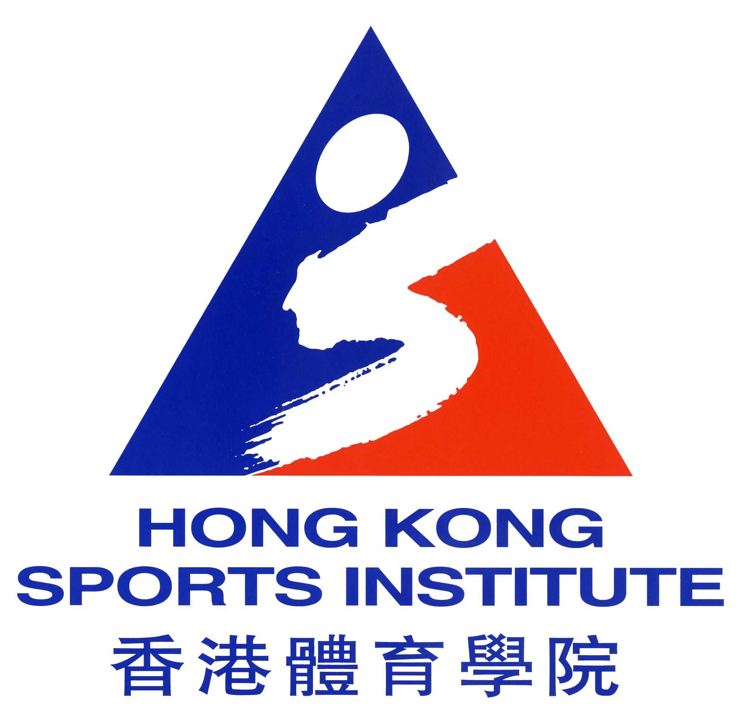

The Hong Kong Sports Institute Limited (“HKSIL”) is dedicated to provide an environment in which sports talent can be identified, nurtured and developed to pursue excellence in the international sporting arena. We are now inviting suitable candidates for the following vacancy:

HEAD BILLIARD SPORTS COACH

THE JOB

The HKSIL works in close collaboration with the Hong Kong Billiard Sports Council (“HKBSCC”) in achieving the jointly defined goals of elite training. Therefore, while reporting to the Chief Executive, the incumbent is also responsible to the HKBSCC to ensure the following duties are satisfactorily conducted:

- To oversee the planning, design, implementation, evaluation, of the Billiard Sports programme in line with the agreed training and competition aims of the HKBSCC and HKSIL;
- To lead the Billiard Sports Department, managing coaching and administrative staff, ensuring that it operates effectively, efficiently and within the annual financial budget;
- To create systematic opportunities for talent to emerge through related programmes so that the development of Billiard Sports is enhanced;
- To ensure that all scientific, medical and other athlete support services are fully utilised and integrated into the Billiard Sports programme to enhance elite training outcomes;
- To contribute technical information to in-house and general media publications as requested;
- To contribute to the enhancement of the professional image of the HKSIL;
- To contribute towards the overall development of coach education programmes which contribute to the development of more and better local coaches; and
- To motivate and train direct reporting coaches to become high quality international coaches.

THE REQUIREMENTS

- Holder of a university degree or equivalent;
- Holder of national level coaching certificates recognized by HKBSCC;
- Over 10 years with a proven record of achievement in coaching Billiard Sports at international level;
- Substantial experience in leading programme planning and administration in Billiard Sports. Knowledge in sports science and sports medicine and be able to bring their benefits to the coaching process;
- Excellent interpersonal / analytical / evaluation / planning skills; and
- High level of computer literacy.

APPLICATIONS

Successful candidate will be remunerated in accordance with qualification and relevant experience. Attractive remuneration package (maximum up to HK$1.5M) will be offered to the right candidate. Please send full resume with current and expected salary, contact telephone number, address and availability to The Human Resources Manager, Hong Kong Sports Institute Ltd, 25 Yuen Wo Road, Sha Tin, New Territories, Hong Kong or email: hrdept@hksi.org.hk on or before 30 March 2010. Please quote reference no. JD-20100316-HBILC in the application.

Appointment will be on a fixed term contract. General information is available at the website http://www.hksi.org.hk. For enquiries, please call Ms Woo at (852) 2681 6343.

All applications will be treated in the strictest confidence. Applicants who are not invited for interview within six months may consider their applications unsuccessful.

Data collected will be used for recruitment and other employment-related purposes only.

